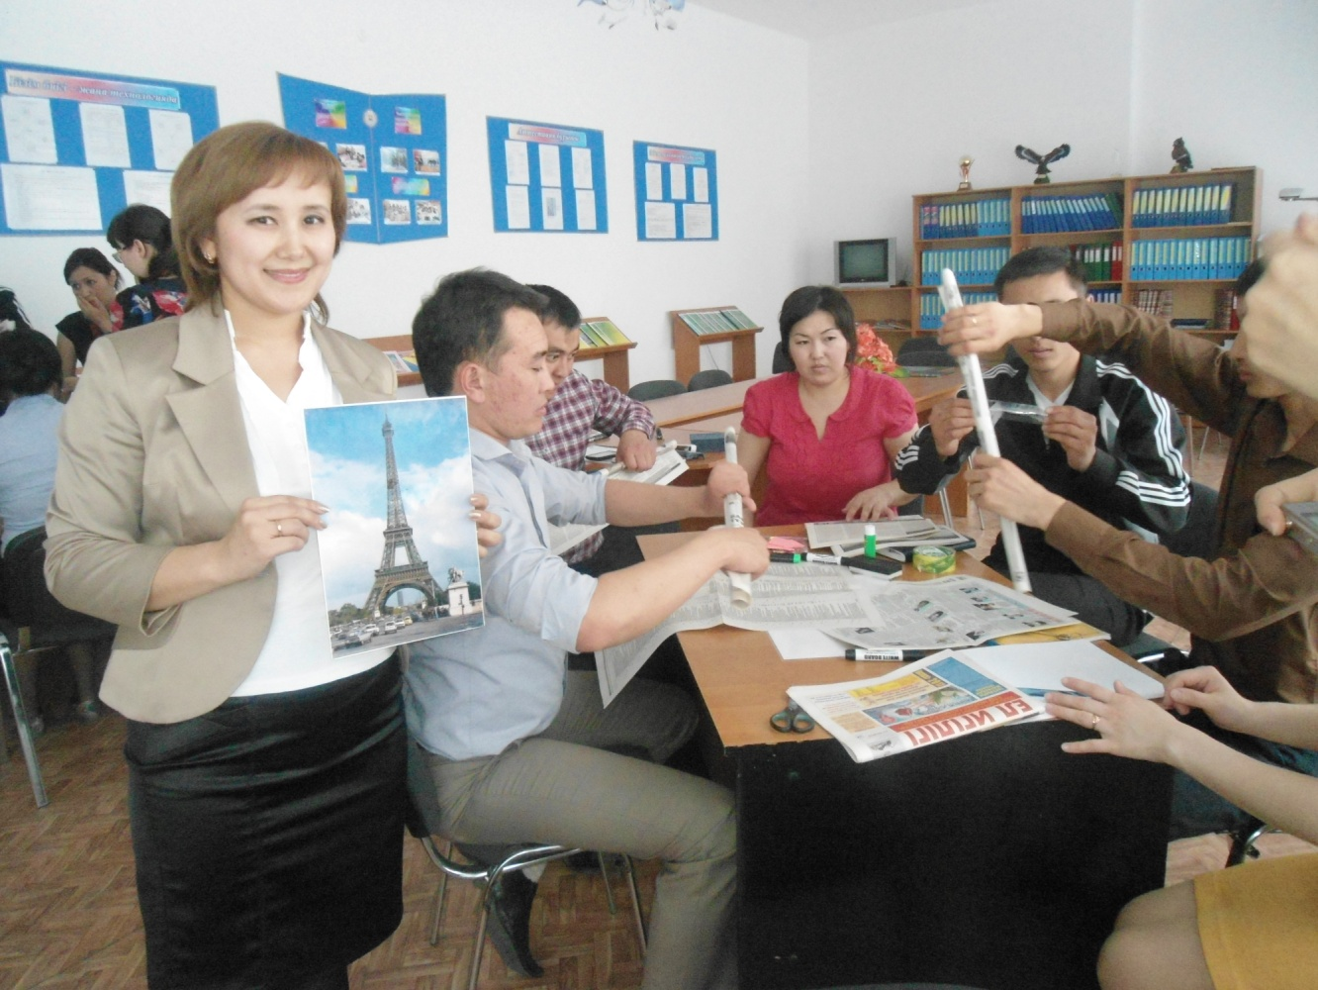**Каршыгина Кунсая Жумахановна,**

Ақтөбе қаласы, М.Арын атындағы

Қарғалы қазақ орта мектебінің

ағылшын тілі пәні мұғалімі

**My favourite food**

|  |  |  |  |  |
| --- | --- | --- | --- | --- |
| **Learning objectives(s) that this lesson is contributing to** | | 2.L4 recognise with support short basic questions relating to features such as colour and number  2.S8 give simple instructions for others to follow  2.R1 read and spell out words for others  2.R4 begin to use with support a simple picture dictionary | | |
| **Lesson objectives** | | **All learners will be able to:** | | |
| respond to some prompts in elicitation and project activities and produce some words and short sentences correctly in their writing and short presentations with support, learn about food from around the world | | |
| **Most learners will be able to:** | | |
| respond to most prompts in elicitation and project activities and produce most words and short sentences correctly in their writing and short presentations with groups, describe the food and provide its usefulness | | |
| **Some learners will be able to:** | | |
| respond to prompts in most activities appropriately and produce most words and short sentences correctly in writing and short presentations independently , describe the food and provide its usefulness | | |
| **Previous learning** | | *Types of food ; names of countries; it’s good for; his/her favourite food;* | | |
| **Plan** | | | | |
| **Planned timings** | **Planned activities** | | **Smiles  Resources** | **Teacher  Notes** |
| Beginning the lesson | Greeting. Training ‘Happy Cicle’. Ask the pupils to present their project from the previous lesson to the class.  Revision of Vocabulary | |  |  |

|  |  |  |  |  |  |
| --- | --- | --- | --- | --- | --- |
| Presentation and practice | **Step 1 Listen and read**. **(activity 1)**  Pupils’ books closed. Refer the pupils to the world map. Point to the UK, Italy and Kazakhstan. Say the name of each country out loud. The pupils repeat after you. Ask the pupils, in L1 if necessary, to tell you what they know about these countries, e.g. capital cities, flags, famous people, food, etc. Explain to the pupils that in this section they will be learning about food from these three countries.  Pupils’ books open. Refer the pupils to the first pictures and ask: Where is Brian from? Elicit: He’s from the UK. Next ask: What’s his favourite food? Say: His favourite food is fish and chips. Why is fish good for us? etc. Do the same for the remaining children. Play the CD. The pupils listen and follow in their books. Then ask individual pupils to read part of the text out loud. | | **Track 69 CD1**  **World Map** | |  |
| **Step 2 Draw, write and present.**  **Short presentation**  Ask the pupils to draw their favourite food from their country. Then they come to the front of the classroom and talk about it. Tell them to use the texts in Ex. 1 as an example. Make sure you display their drawings somewhere in the classroom.  Training ‘Baby Shark ’  Let’s sing a song and dance!  Baby shark do do do  Mummy shark do do do  Daddy shark do do do  Grandma shark do do do  Grandpa shark do do do... | | Group work | |  |
| **Step 3 Individual work**  Match the words with pictures  Muscles Fruit Pasta Cakes Brain Meat  Open microphone” Who is the best?  Do you like an ice-cream?  Yes, I do.  No, I don’t.  Feedback “Traffic light | | **Work with cards** | |  |
| **Additional information** | | | | | |
| **Differentiation – how do you plan to give more support? How do you plan to challenge the more able learners?** | | **Assessment – how are you planning to check learners’ learning?** | | **Cross-curricular links Health and safety check ICT links Values links** | |
| * give extra support with modelling and drilling for presentations and support for writing projects with weaker students in small groups * get stronger learners to check each other’s spellings in written work | | * check handwriting, spelling and sentence formation in writing task and decide on any remedial follow-up tasks | | * cross curricular links: culture around the world / awareness of sounds in the environment | |

