Алмабекова Мақпал Талғатқызы,
Алматы облысы, Талғар ауданы, Бесағаш ауылы,
№ 29 орта мектеп ағылшын тілі пәнінің мұғалім
Module 3 My room Revision. My progress.
Long term plan module: Module 3 My room  Revision. My progress. |  |  |  | School:
Date: 12. 01. 2017
Class: 1 ALL |  |  |  | Number of present; |  | Absent:-
Learning objective(s) that this lesson is contributing to: | 1.L3 recognize with support common names and names of places; recognize the spoken form of a limited range of everyday and classroom words  1.S3 pronounce familiar words and expressions intelligibly  1.R1 recognize sound and name the letters of the alphabet  1.UE8 use simple imperative forms [positive] for basic commands or instructions
Lesson objectives: | All learners will be able to:  sing the some songs with the help of teacher
Most learners will be able to:
give Kazakh meaning of previous words.
Some learners will be able to:
make up dialogues using the previous words.
Language objectives: | Learners can:  By the end of the lesson learners will be able to  - give commands using stamp your feet, jump, sit down, stand up, clap your hands, dance  - sing the song Come on everybody! with the help of teacher
Key words and phrases:
Commands: car, plane, TV, bed, stamp your feet, jump, sit down, stand up, clap your hands, dance
Imperative mood. Clap your hands! Stamp your feet! Jump!
 | Useful classroom language for dialogue/writing: oral
 | Discussion points:
 | Can you say why we have our own rooms?
 | Writing prompts:
Assessment for Teaching | Criteria based assessment  Assessment criteria:  Say about toys, objects.  Giving commands.  Descriptor:  A learner  - gives command to classmates;  - translate the words  - say about his/her toys  Self-assessment: Traffic lights
How to overcome barriers in learning English | Use pair work and group work  -Use toys  -Ask more questions  -Encourage learners to exchange opinions and views in small groups  Total Physical Response
Previous learning | Check point.
Plan
Planned timing |  | Planned activities (replace the notes below with your planned activities)  What will the pupils learn? How will they learn it?  Suggested Teaching Activities  Active Learning activities |  |  |  |  | Resources
Start (Beginning of the lesson) |  | Greeting: Teacher greets learners; learners respond to greeting and take their places. Dividing into subgroups: Teacher divides learners into subgroups counting 1 to 2. Warming up: “Telephone game” Teacher whispers a sentence to the first learner in a line. Learners must then repeat the sentence to the next learner in line and on down the line. The last learner in line will say out loud the sentence as he/she heard it. The first learner in line will either agree or disagree with the sentence. Revising the previous lesson: What toy have you got?  How do you think what theme we have for today? Teacher asks the learners to identify today’s theme using interactive slides. Teacher introduces lesson objectives to the learners. |  |  |  |  | Interactive  board
Middle (of the lesson)  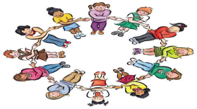 |  | D) Teacher pre-teaches the words using gestures and mimes: stamp your feet, jump, sit down, stand up, clap your hands, dance. Asks the learners to help her. Teacher asks learner to pay attention to sounds. Ex: stamp ‘s’ [sound].  Teacher takes feedback using mimes, gestures.  W) Learners listen to music and find what toys are there?  D) Teacher demonstrates a mime gesture from the dialogue to go with each of the actions above.  Physical drill  Learners  follow teacher’s instructions;  repeat the rhyme.  Listen and do. Repeat after your teacher.  1. Stand up, please! 2. Hands up! Clap - clap!  3. Hands down! Shake - shake! 4. Hands on the hips! Jump – jump!  5. Sit down, please!  G) Class is divided into two lines facing each other. Teacher gives random instructions, e.g. bed, TV, plane, and all learners perform the mime. Teacher gradually speeds up with instructions.  W) Learners listen to and sing the song I have got… with the help of teacher.  W) Learners dance to music and sing the song with pleasure. |  |  |  |  | Song: Come on everybody!, CD, DVD players, picture dictionaries, a worksheet with an empty room outline , room object flashcards, notebook, CD, Student’s book1, Activity Book 1
End (of the lesson) |  | Reflection Self-assessment: smiles  Ask students to look at lesson objectives they set at the beginning of the lesson and think and say what they did well in the lesson and what needs improvement. |  |  |  |  | Traffic lights cards
Additional information:
Differentiation - how do you plan to give more support? How do you plan to challenge the more able learners? |  |  | Assessment - how are you planning to check learners’ learning? |  | Cross – curricular links health and safety check ICT links  Values links
Reflection  Were the lesson objectives / learning objectives realistic?  What did the learners learn today?  What was the learning atmosphere like?  Did my planned differentiation work well?  Did I stick to timings? What changes did I make from my plan and why? |  |  | Use the space below to reflect on your lesson. Answer the most relevant questions from the books on the left about your lesson.

Task 1: What is this?
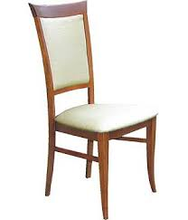
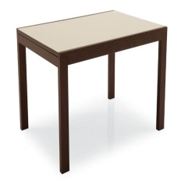
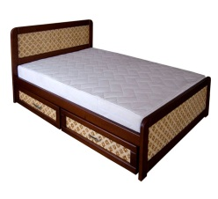

Task

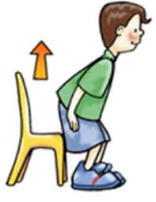
2: Can you give commands?
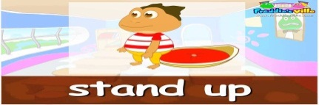

Task 3: Listen and trace.
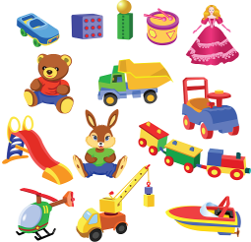

Descriptor: -says about topic words.
-can give command
-works with listening
Criteria | mark | Descriptor | marks
- say topic words with clear pronunciation | 5 | -says about topic words.
-Say expressions clearly | 5  5 | -can give command  -works with listening

