Zhamalova M.,
132 N.Shoibekov secondary school
Music

Unit of a long term plan: Creativity |  |  | School: 132 N.Shoibekov secondary school
CLASS: 5 a |  |  | Number present: | absent:
Lesson title |  | Music
Learning objectives(s) |  | 5 L 6. Deduce meaning from context in short supported talk on an increasing range of general and curricular topics  5 S 3. give an opinion at sentence level on a limited range of general and curricular topics  5 UE 3. use a growing variety of adjectives and regular and irregular comparative and superlative adjectives on a limited range of familiar general and curricular topics
Level of thinking skills |  | Knowledge, Understanding, Application
Lesson objectives |  | All learners will be able to :  - listen and repeat all new words, make up sentences with comparative and superlative adjectives  Most learners will be able to :  - make up sentences to each musical instruments  - compare them using the degrees of adjectives  Some learners will be able to :  - speak about his /her favourite singer
Assessment criteria |  | - Express a point of view in sentences  - Use a growing variety of adjectives and regular and irregular comparative and superlative forms in their speech.
Values links |  | Know and respect folk music and folk musical instruments
Cross-curricular link |  | Music , Art Кazakh
Previous learning |  | Sum up what learners have learnt about this topic so far.
Plan
Planned timings | Planned activities (replace the notes below with your planned activities) |  |  |  | Resources
Start  10 min | 1. Greeting & org . moment  - What did we learn at previous lesson ?  Teacher introduces pupils with the theme, learning objectives and assessment criteria.  Divide into groups ‘dombyra’ and “ kobyz”.  Find out your piece of picture  Let’s watch a video and you will understand the theme of our lesson.  Activity “ Numbers speak”  - What did you understand from this video?  - Is music necessary in our life?  - Do you remember kinds of music and musical instruments?  Differentiation question for more able student:  - Do you think that music can change your lives? Why ?  AFL : oral feedback |  |  |  | Excel  Divide into groups with the pictures of violin and piano.  Videoclip about music https://www.youtube.com/watch?v=wiF8YlKNx4g  Cards with numbers
Middle  - min | G. 2. Listen and match the types of music A-H to the musical instruments in the pictures. Make up sentences with musical instruments.  A classical b rock c jazz d folk e heavy metal f disco g pop h ethnic  1 acoustic guitar 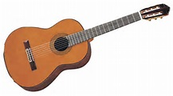  2 synthesiser 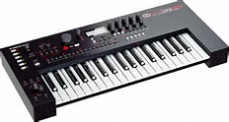 3 saxophone 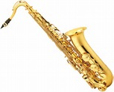  4. harp 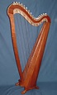  5 drums 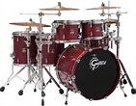  6 cello 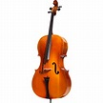 7 violin 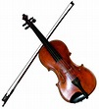  8 piano 9 accordeon  Descriptors : A learner  - listens to the text carefully  - matches types of music with the musical instruments in the pictures.  - Say simple sentences using instruments.  AFL : Oral feedback  AFL : Expert Envoy  - 4. Speak about your favourite singer (individual work )  Differentiation question for more able student:  Why do you like this singer ? What do you know about his/ her lifestyle ?  Descriptors : A Learner :  - speaks about his/her favourite singer  - adds information about his /her biography  - adds information about his/ her carreer  - says why does he/she like him /her  AFL : voting |  |  |  | Photos of musical instruments on the interactive board or on a computer  Excel  Excel
End  5 min | (G) 3. Make up sentences and compare the using the degrees of adjectives  - Group “ dombyra” compare and kobyz  - group “ ” will compare dombyra and kobyz  AFL : Praising “ You are, you are super !” for winner group.  Teacher encourages more able learners to help those students who need some help.  Hometask |  |  |  | Board
Additional information

