Сейтжанова Тлеуле Нұрсапақызы
Райымбек батыр атындағы №50
«Қазғарыш» мектеп-лицейі, ағылшын тілі пәні мұғалімі,
Астана қаласы
Welcome to The USA! Grade 8
Aims: Educational: To give i nformation about the USA.The largest cities and states of the USA.
Developing: To develop students’ communicative skills and abilities using various kinds of activities, training in speaking, reading, writing.
Bringing-up: To bring up love to our country and love to the country which we learn their language.
Methods of teaching: explanation, demonstration, presentation, working with tables,
Inter-subject connection: Kazakh, Russian, Geography,
The equipment of the lesson: an interactive board, cards, pictures, posters, test, quiz, A3 papers for wall story, Internetmaterials...
The Procedure of the lesson
I. Organization moment and conversation with duty/ Greeting.
T: - Good day, students! I’m glad to see you at our English lesson. Let’s start our lesson with good wishes. Please, make a circle and greet each other.
P-P: - I wish you success! I wish you luck! I wish you health! I wish you happiness! Be pretty! Be boldness! Be modest! Be powerful! Be clever! Be honesty! Be beautiful! Be handsome!,,,
II. 1. Brainstorming: Proverbs/English, Russian , Kazakh/
Before beginning our lesson I want to remember you that there is going our English ten days. The theme of our English ten days is “EXPO-2017 the world comes to Kazakhstan». That’s why we know that EXPO-2017 will be held in Astana. Now, students! What do you know about EXPO-2017?

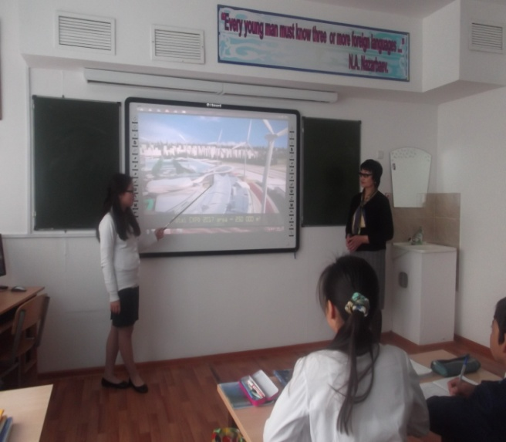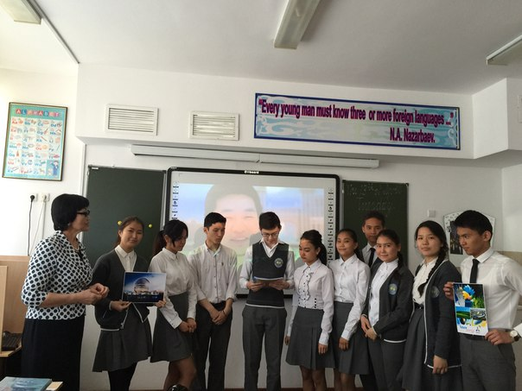

Students: 1. EXPO -2017is a recognized exploit’s also referred to as an international specialized expo.
2. EXPO-2017 is a part of World’s Fair System.
3. Recognized expos are smaller versions of the universal expos referred to as World’s Fairs.
4. Recognized expos center on a particular theme and are held between World’s Fairs, which occur every 5 years.
4. Kazakhstan has chosen the theme “Future Energy” to promote and discover sustainable, global energy solutions..
III. Review. Teacher: You know the USA is one of the visitors to EXPO-2017 in Astana.
I am very glad to see you at our lesson today because we have an unusual lesson. You will show our guests your knowledge of the United States of America because our lesson is devoted to this country. We’ll speak about the sights, the traditions, the presidents and interesting facts.
At First, answer the questions about geographical position of the United States.

- When was America discovered? (1492)
- Who was discovered Americaby? (Christopher Columbus)
- What is the official language in America? (English)
- What is Americans money? (dollars, cents)
- What is the national symbol? (Bald eagle)
- What can you say about Americans flag? (50 stars, 13 stripes, white, red colors)
- Who was the first President of the USA? /G. Washington/
- Name the largest cities of the USA?/ Washington New York Los Angeles/
- How many states have The USA? /50/
- What is America’s largest state? (The largest state is Alaska).
- Who is the President of the USA nowadays?
- What oceans is the USA washed by? (It is washed by the Atlantic Ocean and by the Pacific Ocean)
- What is the longest river in the USA? (The longest river in the USA is the Mississippi river).
- What is the highest mountain peak in the USA? (.is Mount McKinley).
- How many time zones is the continental part of the USA divided into? (.. is divided into 4 time zones).
- Name the fine Great Lakes, please. (They are Lakes Huron, Erie, Ontario, Michigan, and Superior).
- What Americans holidays do you know?
- When do Americans celebrate the Independence day? (July,4)
III. Checking home task. You must be ready for retelling of the information about the USA and its largest cities and largest states. Please, go to the blackboard, and present your work.
IV. Bloom’s chamomile 1, 2,3,4,5,6,7,8? Teacher: The fourth task is to explain the meaning of the word written on the card in English. You know, America has a lot of different places of interest. It is famous for its monuments, well-known buildings and other sights. Each team must take four cards. Read these words and explain their meanings. Disneyland, the White House, the Statue of Liberty, “The Pencil”, Congress, Harlem, Hollywood, the Empire State Building.

- Disneyland is a large amusement park for children in Southern California created by the American film producer Walt Disney in 1955.
- The White House is the official home of the President of the USA where he works and lives.
- The Statue of Liberty is the symbol of freedom in America. It is a bronze figure (almost 46 meters high) of a woman holding up a torch, on Liberty Island in New York Harbor which is a gift from the French government sent to America in 1884.
- “The Pencil” is the name of the tall column in Washington, D.C., that is the Washington Monument built in honor of the first President of the USA.
- Congress – is the parliament of the USA which has its seat in the Capitol.
- Harlem is considered to be the poorest district in New York where mainly Afro – Americans live.
- Hollywood is associated with the US film industry. It is situated not far from Los Angeles. It is the world – famous center of films.
- The Empire State Building is one of the tallest buildings in the world (381 meters high) in New York City. It is a skyscraper.
- National anthem of the USA. Music “America the beautiful”. Listening to music
V. Reading. The Presentation of the new theme of theslesson. «The United State*s Economy» Now, let`s continue our lesson. Would you like to go to the USA? Today, we have known about this country especially about the USA about states and large cities.
1. What are the leading manufacturing products of the USA?
2. I will give out A3 papers for wall story. You must draw a chart about your texts. You can use dictionary.1. read the text for information ``The United State’s Economy ``
2. do the diagram and say what have you known from it.
3. answer the questions.
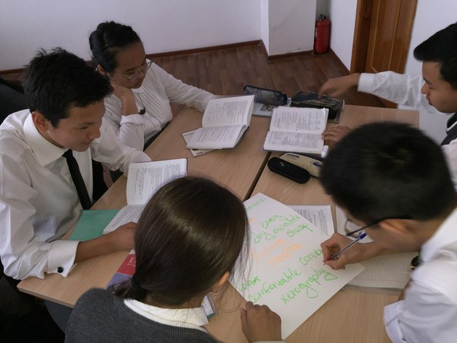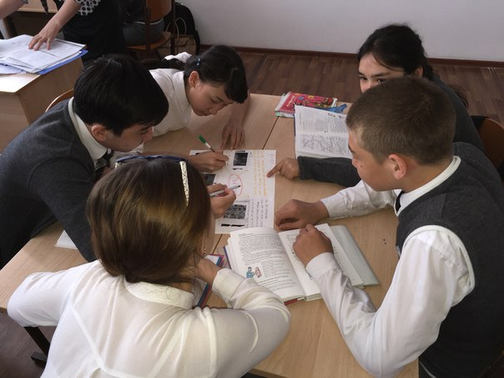

2. What are the leading farm products of the USA?
VI. Game. “Guess who it was?” Teacher: Well done, thank you. The following task for you is “Guess who it was?” You should put the passages of the story in the right order, read them aloud and tell me what American Presidents this story is about.Who was it?/George WashingtonAbraham Lincoln/
1.He was born when most of America was still a wilderness. The British had 13 colonies on the eastern coast. In 1776 war broke out between the colonies and their mother country, because the colonies wanted independence. He was the leader of the American army.After 7 years of fighting the British gave up the war and the colonies became an independent country with the name of the USA.He was made President and his name was given to the capital of the young nation.
2. He was born in a big log – cabin. He was the son of very poor parents, but he worked his way up and finally became President in 1860.At that time there was a trouble between the Northern and Southern states. The Northern believed that slavery was wrong and that no one should be allowed to keep slaves. The Southerners said they could not grow cotton and tobacco without slaves.When he became President, the Southerners declared that they would leave the Union and form their own government. The terrible Civil war broke out – it lasted 4 years. This President saved the Union and gave freedom to all American slaves.
About Meals of the USA. -Alua, Dinner-Dameli, Supper-Azel.
VII. Consolidation. “The USA Quiz” (Answer these questions about the United States of America. Put a + next to the correct answer.) Keys: 1-b2-c3-c4-a 5-c 6-b7-a8-b9-c10 - b
1. Where does the President of the United States live and work?
A. In Congress B.InThe White House C.InThe Pentagon
2.Which is the biggest state in the USA?
A.Texas B.California C.Alaska
3.How many States are there in the USA?
A.48 B.52 C.50
4.Who was the first president of the USA?
A.George Washington B.Abraham Lincoln C.Ulysses Grant
5.In which city is Hollywood?
A.New York B.San Francisco C.Los Angeles
6.What do the Americans celebrate on the 4-th of July?
A.The first moon landing B.Declaration of Independence C.The end of the American Civil War
7.What is the nickname of New York?
A.Big Apple B.Big City C.Big Jack
8.By whom was the first American car made?
A.By Smith B.By Ford C.ByIvanov
9.On what holiday do children say “Trick or treat! Money or eat!”?
A.On Christmas B.On New Year .On Halloween
10. Who is the head of state in the USA?
A.The British Monarch B.The President C.The prime Minister

VIII. Listening.
The Origin of the Word “America”
For a while after the first voyage of Columbus in 1492, America was called the “New World”. Later, however it was decided by mapmakers in Europe to name the new World after a man named Amerigo Vespucci. He was an Italian merchant and adventurer who made three trips to the New World. Columbus became the first explorer to reach the mainland of South America in 1498, but Amerigo Vespucci soon wrote a book in which he claimed to have gone there in 1497. This was not true but people did not know for many years that Amerigo Vespucci was lying
Teacher: Answer the question “Why America is named like this?”

IX. Conclusion.
T: - So our lesson is coming to the end. I hope you remembered all information about the USA.
Thank you for your good work today.

XII. Giving marks.
T: - Thank you for your lesson. Now please, the leaders of the groups say the students* marks.

X. Reflection.
T: - Now, you have different colours of stickers. And in this, you may write your opinion about today’s lesson and stick on the blackboard.

XI. Home task. About Economy of Kazakhstan. Read the text, retell, think of 5 questions to the text Ex.1.page 196. Divide in 5 groups and make 5 projects about the 5 industrial sectors.

XIII. The end of the lesson: Now Students! You are very active today. Thank you very much! And Dear guests, Thank you for your attention. Our lesson is over.

