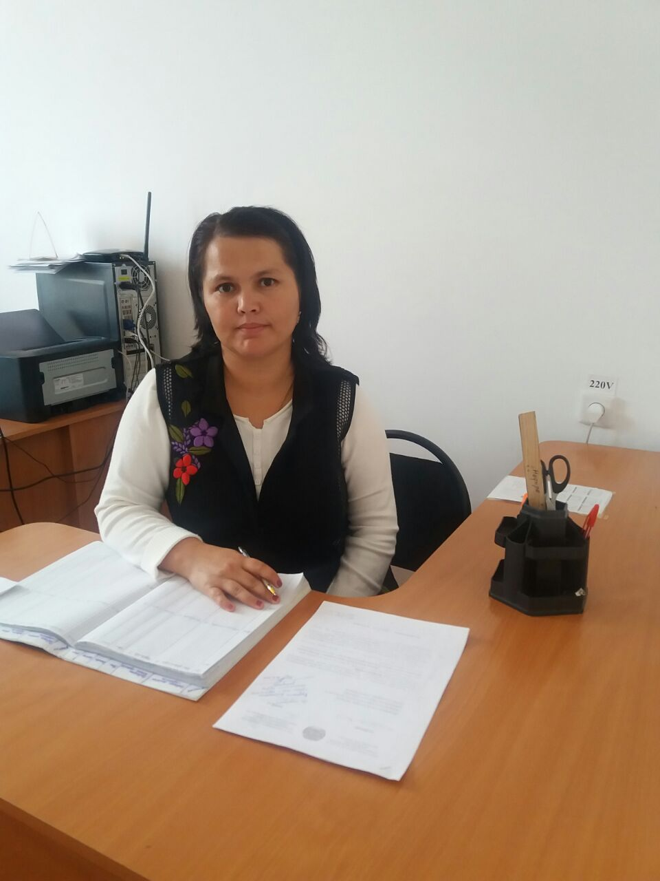

Ушибаева Индира Маратовна
Науайы атындағы жалпы орта мектебі,
ағылшын тілі пәні мұғалімі,
Оңтүстік Қазақстан облысы,
Созақ ауданы, Созақ ауылы,

Modal Verbs. Sports
Сыныбы: 9
The theme: Modal Verbs. Sports.
The type of the lesson: combined
The aims: 1) to get information about sport and its role in our life.
2) to develop speaking, reading, writing skills, to teach the students to express
their opinions about the role of sport in our life
3) to develop critical thinking, solving problems
Connection with other subjects: physical education, Russian, Kazakh.
Visual aids: an interactive board, writing blackboard, cards, the posters etc.
The course of the lesson:
Organization moment:
Greeting - Good morning!
- Good morning teacher!
- How are you?
- I’m fine, and you?
- I’m fine too, thank you, sit down please!
The report of the pupil on duty
- Who is on duty today?
- I’m on duty today.
- Who is absent today?
- All are present.
- What date is it today?
- What day of the week is it today?
- Today is __________.
- Well, thank you, sit down, please.
Checking of the home task:
What was your home task? I’ll check your home task. Please open your copy-books.
Warm up:
You can swim and play football,
Hockey, tennis, basketball.
You can jump and you can run.
You can have a lot of fun!
New theme:
Today’s lesson theme is grammar material Modal Verbs and Sport in my life. You’ll know different kinds of sports, kinds of modal verbs, and do some more exercises, and find out sport is important in our life. And the sports are useful for our health.

Brainstorm:
- What is your favourite sport? My favourite sport is ….
- Why do you like it? - What sport do you go in for? I prefer ……
- What kind of sports do you know? I know ……

Жаңа сабаққа нұсқау беру - Grammar theme is Modal verbs.
Модаль етістіктің түрлері: Can-істей алу, may- істей алу/рұқсат/, must-міндетті, should-ақыл кеңес бергенде керек, қажет.
- Модальді етістіктер ешқандай әрекетті білдірмейді, олар тек қана сөздің шындыққа қатынасын ғана көрсетеді. (мүмкіншілікті, ықтималдықты, қажеттілікті).
- Модальды етістіктің ерекшеліктері:
- Модальды етістіктен кейін инфинитив “to” демеулік шылауынсыз қолданылады.
- Олар жекеше түрде де, көпше түрде де, жақта да ешқандай өзгеріске түспейді.
- Сұраулы сөйлемде етістіктер бастауыштың алдында тұрады. Must I read or translate?
- Болымсыз сөйлемде not етістіктен кейін тұрады. Not can етістігімен бірге жазылады: cannot, can’t.
Must I go there? – I mustn’t go there.
May I come in? – Yes, you may.

Work with new words. Please write down, translate and find out the words in the picture

Athlete [‘æӨli:t]- атлет
Boxing [bɔksiŋ]- бокс
Baseball [beisbɔ:l]- бейсбол
Basketball [‘ba:skitbɔ:l]-баскетбол
Cricket [‘krikit]-крикет
Football [‘futbɔ:l]-футбол
Golf [gɔlf]-гольф
Gymnastics [dʒimnæsticz]-гимнастика
Horse racing [hɔ:s reisiŋ]-атқа міну
Ice hockey [‘ais hɔki] –хоккей
Swimming [swimiŋ] -жүзу
Tennis [‘tenis]-теннис

Read and repeat after me. Then translate it.
Match the words with the pictures

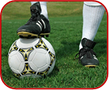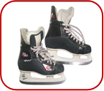
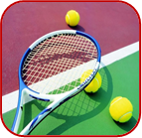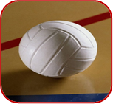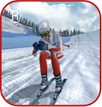

Өздік жұмыстар
Put the offers on the interrogative forms.
- I can do the work.
- She must go.
- He may come in.
- He can speak English well.
- We must work at our project today.
2. Translate from Kazakh into English
- Олар сабақ үстінде қазақ тілінде сөйлесулері керек.
- Менің сізбен бірге баруыма болады ма?
- Ол ағылшын тілінде сөйлей алады ма?
- Сіз менің сұрағыма жауап бере аласыз ба?
- Маған кіруге болады ма?

Work in groups.
Draw a diagram. What kind of Kazakh and Britain sports do you know?
You must fill it. Hang up your posters.
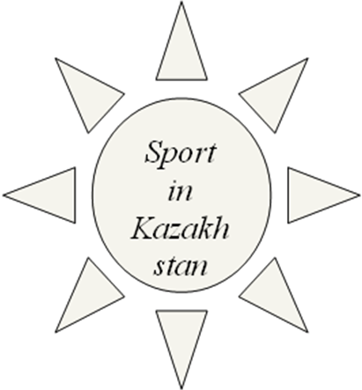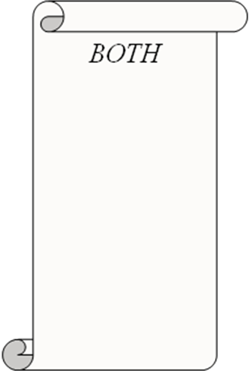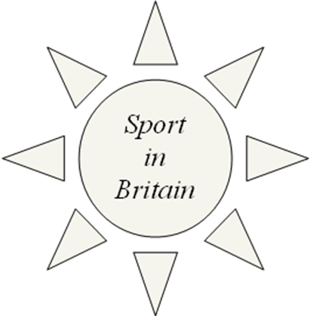

Group A. We want to say about Kazakh National games. There are Kyz-kuu, Kokpar, Audaryspak.
Group B. We want to give an information about Sport in Britain. They are Cricket, Netball, baseball etc.

Make up the dialogues in groups.
Алған білімін қолдану
Definition. Can you guess what sports and games are described here?
a.the sport of fighting with fists;
b.the sport of riding in a small boat with sails;
c.the sport of one who swims;
d.the sport of playing a type of football with an oval ball;
e.a game for two people who use rackets, a small soft ball and a low net;
f.the sport of moving through the water in a boat without sails;
g.the sport of going on horseback;
h.a game played by two teams of 6 players each that is played on an ice field.
Keys:
- boxing;
- sailing;
- swimming;
- rugby;
- tennis;
- rowing;
- horse racing;
- ice hoсkey;
Hometask: Make up the dialogue and make up sentences
Giving marks

